Mathematics Family Letter, Unit 2

Dear Family,
Our class is starting a new unit in math called Decimals. In this unit, students will learn decimal place values. They will compare decimals and solve expressions with decimals. This work can be challenging to students.

At the end of this unit, students will:
- Understand place value of decimals to the thousandths place
- Read, write and compare decimals using models or drawings
- Add and subtract decimal numbers using different strategies
- Make real world connections to decimals

Each student should be able to answer/solve questions like the following:

- Put the numbers 0.37, 0.4, and 0.04 in order from greatest to least.
Answer: 0.4, 0.37, 0.04
The tenths place has a larger value than the hundredths place.
- Write the number 43.269 in expanded form.
Answer: 40 + 3 + .2 + .06 + .009
- Write the number 43.269 in word form.
Answer: Forty three and two hundred sixty nine thousandths
- What is 8.73 + 3.52? How do you know?
Answer: 12.25
8 + 3 = 11, and 0.73 + 0.52 = 1.25; add 11 and 1.25 to get 12.25
- What is 8.73 - 3.52? How do you know?
Answer: 5.21
8 – 3 = 5, and 0.73 – 0.52 = .21
- Steve goes to a restaurant and buys a meal: sandwich, chips, and drink. Including tax, the meal cost $7.34. He gives the cashier $10.00. How much change should Steve receive? (Answer: $2.66)

Example of addition with decimal numbers:
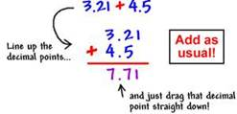

Example of subtraction with decimal numbers:
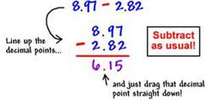

In our math class students spend time discussing and sharing their reasoning and solutions. It is important that children solve problems in ways that make sense to them. Encourage your child to explain their mathematical thinking and solutions with math vocabulary at home.

Sincerely,
Ms. Gruber & Ms. Carroll

